GCNU1003 Speaking of Statistics (2014-2015) Assignments Ch.1-Ch.2

- True / False Questions
- A population is a set of existing units. ( )
- If we examine some of the population measurements, we are conducting a census of the population. ( )
- A quantitative variable can also be referred to as a categorical variable. ( )
- Statistical inference is the science of using a sample of measurements to make generalizations about the important aspects of a population of measurements. ( )
- The science of describing the important aspects of a set of measures is called statistical inference. ( )
Ans: a. TRUE b. FALSE c. FALSE d. TRUE e. FALSE

- Below we list several variables. Which of these variables are quantitative and which are qualitative?
a. The dollar amount on an accounts receivable invoice.
b. The net profit for a company in 2005.
c. The stock exchange on which a company’s stock is traded.
d. The national debt of the United States in 2005.
e. The advertising medium (radio, television, or print) used to promote a product.

Ans： a. Quantitative; dollar amounts correspond to values on the real number line.
b. Quantitative; net profit is a dollar amount.
c. Qualitative; which stock exchange is a category.
d. Quantitative; national debt is a dollar amount.
e. Qualitative; media is categorized into radio, television, or print.

- The National Automobile Dealers Association (NADA) publishes AutoExec magazine, which annually reports on new vehicle sales and market shares by manufacturer. As given on the AutoExec magazine website in May 2006, new vehicle market shares in the United States for 2005 were as follows:
Company | 2005 Market Share (%)
Chrysler/Dodge/Jeep | 13.6%
Ford | 18.3%
GM | 26.3%
Japanese(Toyota/Honda/Nissan) | 28.3%
Other | 13.5%
Please use software to construct a percent frequency bar chart and a percentage pie chart for 2005 auto market shares.
Ans:
- Figure 2.5 gives a percentage pie chart of new vehicle market shares in the U.S. for 2010 as given by GoodBadCar.net. Use this pie chart and your results from Exercise 3 to write an analysis explaining how new vehicle market shares in the Unities States have changed from 2005 to 2010.
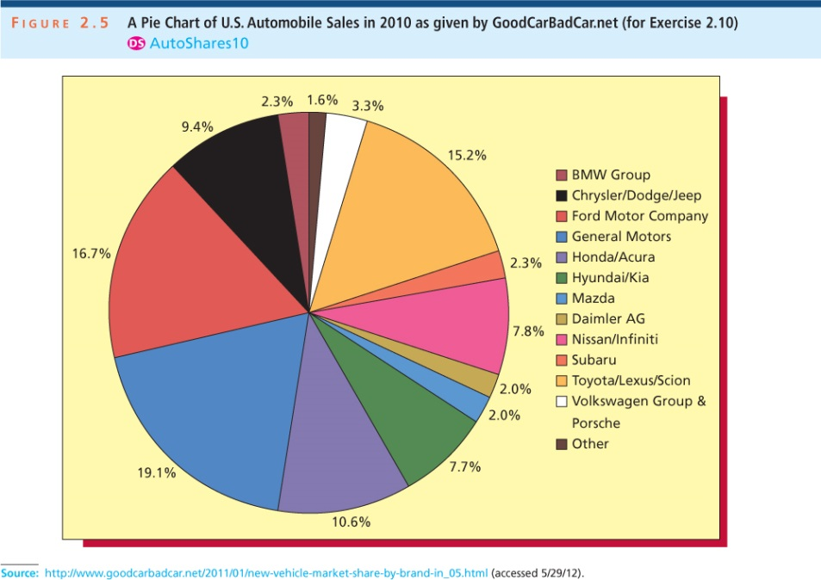
Ans: Comparing the two pie charts they show that since 2005 Ford & GM, have lost market share, while Chrysler and Japanese models have increased market share.
THE MARKETING RESEARCH CASE
60 randomly selected shoppers have rated a new bottle design for a popular soft drink. The data are given below.
34 | 33 | 33 | 29 | 26 | 33 | 28 | 25 | 32 | 33
32 | 25 | 27 | 33 | 22 | 27 | 32 | 33 | 32 | 29
24 | 30 | 20 | 34 | 31 | 32 | 30 | 35 | 33 | 31
32 | 28 | 30 | 31 | 31 | 33 | 29 | 27 | 34 | 31
31 | 28 | 33 | 31 | 32 | 28 | 26 | 29 | 32 | 34
32 | 30 | 34 | 32 | 30 | 30 | 32 | 31 | 29 | 33
Use these data to work with Exercises 5 and 6.
- a. Find the number of classes that should be used to construct a frequency distribution and histogram for the bottle design ratings.
b. If we round up to the nearest whole rating point, show that we should employ a class length equal to 3.
c. Define the nonoverlapping classes for a frequency distribution, tally the number of ratings in each class and develop a frequency distribution.
d. Draw the frequency histogram for the ratings data, and describe the distribution shape.
Ans:
a. 6 classes because there are 60 data points (from Table 2.5).
b. Class Length (CL) = (35 – 20) / 6 = 2.5 and we round up to 3.
c.
 | Rating |  |  |  |  |  | cumulative
lower |  | upper | midpoint | width | frequency | Percent | frequency | percent
20 | < | 23 | 21.5 | 3 | 2 | 3.3 | 2 | 3.3
23 | < | 26 | 24.5 | 3 | 3 | 5.0 | 5 | 8.3
26 | < | 29 | 27.5 | 3 | 9 | 15.0 | 14 | 23.3
29 | < | 32 | 30.5 | 3 | 19 | 31.7 | 33 | 55.0
32 | < | 35 | 33.5 | 3 | 26 | 43.3 | 59 | 98.3
35 | < | 38 | 36.5 | 3 | 1 | 1.7 | 60 | 100.0
 |  |  |  |  | 60 | 100.0
d.
Distribution shape is skewed left.

- Use a software to draw a frequency histogram for the bottle design ratings.
Ans: Results using Excel (Textbook Page 80)
bin | Frequency
20 | 1
22 | 1
24 | 1
26 | 4
28 | 7
30 | 11
32 | 19
34 | 15
36 | 1
More | 0

Results using MegaStat (Textbook Page 86)
 | Rating |  |  |  |  |  | cumulative
lower |  | upper | midpoint | width | frequency | percent | frequency | percent
20 | < | 22 | 21 | 2 | 1 | 1.7 | 1 | 1.7
22 | < | 24 | 23 | 2 | 1 | 1.7 | 2 | 3.3
24 | < | 26 | 25 | 2 | 3 | 5.0 | 5 | 8.3
26 | < | 28 | 27 | 2 | 5 | 8.3 | 10 | 16.7
28 | < | 30 | 29 | 2 | 9 | 15.0 | 19 | 31.7
30 | < | 32 | 31 | 2 | 14 | 23.3 | 33 | 55.0
32 | < | 34 | 33 | 2 | 21 | 35.0 | 54 | 90.0
34 | < | 36 | 35 | 2 | 6 | 10.0 | 60 | 100.0
 |  |  |  |  | 60 | 100.0

- Fill in the missing components of the following frequency distribution constructed for a sample size of 50.
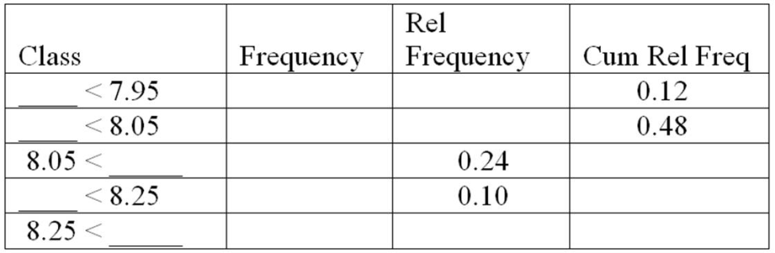
Ans:
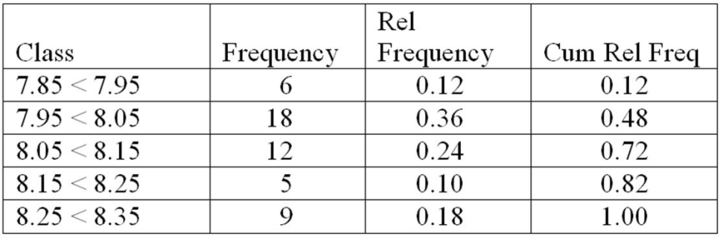

- The following data consist of sales figures (in millions of dollars) for a group of 20 firms. Construct a stem-and-leaf display for these data. Use a leaf unit equal to 100.
6835 | 3517 | 1973 | 1449 | 2820 | 2384 | 5358 | 1376 | 1233 | 1725
3291 | 6047 | 2707 | 7903 | 3291 | 4616 | 2675 | 1541 | 3707 | 4189
Ans:
Rounding each measurement to the nearest hundred yields the following stem & leaf

Stem unit = 1000, Leaf Unit = 100
Frequency | Stem | Leaf
5 | 1 | 2 4 4 5 7
5 | 2 | 0 4 7 7 8
4 | 3 | 3 3 5 7
2 | 4 | 2 6
1 | 5 | 4
2 | 6 | 0 8
1 | 7 | 9
Total 20

- THE TRASH BAG CASE Figure 2.22 gives a stem-and-leaf display of 40 breaking strengths in the trash bag case.
a. Use the stem-and-leaf display to describe the distribution of breaking strengths.
b. Write out the 5 smallest breaking strengths as they would be expressed in the original data.
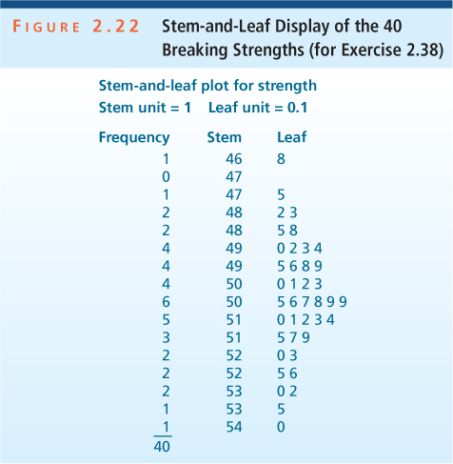
Ans: a. Distribution is symmetric
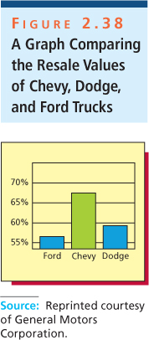
b. 46.8, 47.5, 48.2, 48.3, 48.5.
- Figure 2.38 was used in various Chevrolet magazine advertisements in 1997 to compare the overall resale values of Chevrolet, Dodge, and Ford trucks in the years from 1990 to 1997. What is somewhat misleading about this graph?
Ans: The graph indicates that Chevy trucks far exceed Ford and Dodge in terms of resale value, but the y-axis scale is misleading.

